# Airflow Redirector Collection

## Purpose and Use

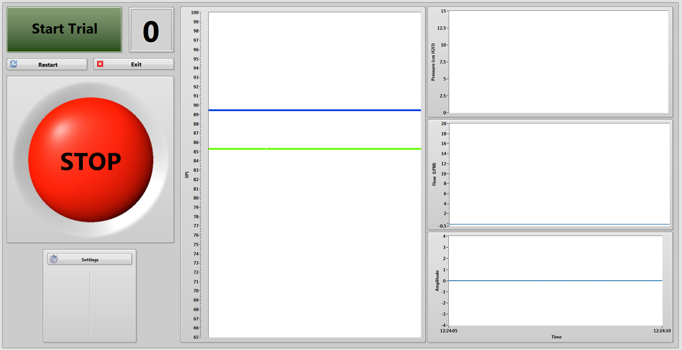This program is used to collect data using the airflow redirection device. Programmatically, this works the same way as the complete interruption program. The main differences are in the data save locations, and the front panel layout.

I probably did not need to make this write-up page. Just look at the complete interruption section and you will be able to understand how this one works.